Cookies, Coffee & Craft Corner

FREE Drop-In for Adults

Wednesday, February 13, 1-2pm
Oxford Riverside Art Gallery

This hour is yours:
Enjoy the craft project being offered;
OR bring your own to work on;
OR just join us for a chat

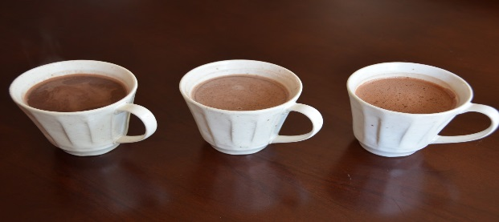

and have a coffee, hot chocolate or tea.
“Bringing People Together”

For more information, contact: Ruthie Patriquin,
Oxford’s Community Economic Development Officer
902 447-2250

